**THE SUPERIOR COLLEGE LAHORE**

|  |
| --- |
|  |

**Faculty of Computer Science & IT**

**Department of Software Engineering**

**Final Year Project**

**PROJECT REPORT (Part-1)**

**[Home Appliances Mobile App]**

Project ID: **[write ID here Issued by FYP Manager]**

**Project Team**

|  |  |  |  |  |
| --- | --- | --- | --- | --- |
| **Student Name** | **Student ID** | **Program** | **Contact Number** | **Email Address** |
| Imran Hameed | BCSM-S17-068 | BSCS | 03054584320 | Imranhamid47@gmail.com |
| Saba Razzaq | BCSM-F16-467 | BSCS | 03126587190 | BCSM-F16-467@superior.edu.pk |
|  | ……………… | ……. | ………………….. | …………………………. |

**Project Report**

**[Electronic-based former]**

**Change Record**

|  |  |  |  |  |
| --- | --- | --- | --- | --- |
| **Author(s)** | **Version** | **Date** | **Notes** | **Supervisor’s Signature** |
|  | 1.0 |  | <Original Draft> |  |
|  |  |  | <Changes Based on Feedback from Supervisor> |  |
|  |  |  | <Changes Based on Feedback From Faculty> |  |
|  |  |  | <Added Project Plan> |  |
|  |  |  | <Changes Based on Feedback from Supervisor> |  |
|  |  |  |  |  |
|  |  |  |  |  |
|  |  |  |  |  |
|  |  |  |  |  |
|  |  |  |  |  |

**APPROVAL**

|  |  |
| --- | --- |
| **Project Supervisor** | |
| Comments: ___________________________________________________________________ | | |
| _____________________________________________________________________________ | | |
| Name:______________________________ |  | |
| Date:_______________________________ | Signature:__________________________ | |

|  |  |
| --- | --- |
| **Project Manager** | |
| Comments: ___________________________________________________________________ | |
| _____________________________________________________________________________ | |
|  |  |
| Date:_______________________________ | Signature:__________________________ |

|  |  |
| --- | --- |
| **Head of the Department** | |
| Comments: ___________________________________________________________________ | |
| _____________________________________________________________________________ | |
|  |  |
| Date:_______________________________ | Signature:__________________________ |

**Dedication**

*This work is dedicated to all of those who wish’s me Good luck Prayers and support me All my teachers who help me out for completing this project Specially our supervisor Sir Fawad, Project Manager sir Zaman Aziz, HOD Dr. Irfan u din and Dean Dr. Shaheryar. They support us and lead to complete our work. Special thanks to my parents who support me pray for me. I really appreciate to my family who is supporting me as financially, and also my friends who is working day and night to complete this Project.*

**Acknowledgements**

O Allah, it’s all yours blessing on me, you bestowed me strength for my study and,

In the making of this project.RAHMAT-AL-LIL AALAMEEN HAZRAT MUHAMMAD (SALLALAHO ALAIHI WASALLUM) said:“On the Day of Resurrection, the ink of the scholars will be weighed up against the blood of the martyrs, and the ink of the scholars will preponderate over the blood of the martyrs.” [Reference: Tafsir al-Durr-al-Manthur, volume 3, no. 423]

I am really thankful to my supervisor Sir Fawad who has a good knowledge and have best capability to treat us .Our supervisor Sir Fawad are very punctual and very good to us and give us some of our extra time to manage our problems, although he had busy schedule managing classes and other university related affairs.

We have too many people to thank for this project to fit everyone in, so we’d like to start out by thanking everybody who helped us. Actually, we couldn’t have done it without you, if we don’t mention you here!

**Executive Summary**

Home Appliances app is a mobile application which will help people/buyers to buy home appliances. Currently, most people go to one or two outlets and buy what they want without knowing that the same product is available in low price or with discount from the next outlet and they spend their hours in searching of showrooms/outlets and discounts. Mostly people don’t want to visit more than 3 outlets of different companies or don’t want to roam around the city.

This mobile application will help user to search any home appliance from the outlets/showrooms nearby (by using location services), collect its price information from different outlets/showrooms and compare it for best offer.

This application will help users with home delivery services all over the city and it will also provide repairing and maintenance services for home appliances.

This app will help sellers/outlets to sell their products online in easy and efficient way.

**Table of Contents**

Dedication iv

Acknowledgements v

Executive Summary vi

Table of Contents vii

List of Figures ix

List of Tables x

Chapter 1 1

Introduction 1

1.1. Background 2

1.2. Motivations and Challenges 2

1.3. Goals and Objectives 2

1.4. Literature Review/Existing Solutions 2

1.5. Gap Analysis 2

1.6. Proposed Solution 2

1.7. Project Plan 3

1.7.1. Work Breakdown Structure 3

1.7.2. Roles & Responsibility Matrix 3

1.7.3. Gantt Chart 3

1.8. Report Outline 3

Chapter 2 4

Software Requirement Specifications 4

2.1. Introduction 5

2.1.1. Purpose 5

2.1.2. Document Conventions 5

2.1.3. Intended Audience and Reading Suggestions 5

2.1.4. Product Scope 5

2.1.5. References 6

2.2. Overall Description 6

2.2.1. Product Perspective 6

2.2.2. Product Functions 6

2.2.3. User Classes and Characteristics 6

2.2.4. Operating Environment 7

2.2.5. Design and Implementation Constraints 7

2.2.6. User Documentation 7

2.2.7. Assumptions and Dependencies 7

2.3. External Interface Requirements 8

2.3.1. User Interfaces 8

2.3.2. Hardware Interfaces 8

2.3.3. Software Interfaces 8

2.3.4. Communications Interfaces 9

2.4. System Features 9

2.4.1. System Feature 1 9

2.4.1.1. Description and Priority 9

2.4.1.2. Stimulus/Response Sequences 9

2.4.1.3. Functional Requirements 9

2.4.2. System Feature 2 10

2.4.2.1. Description and Priority 10

2.4.2.2. Stimulus/Response Sequences 10

2.4.2.3. Functional Requirements 10

2.4.3. System Feature 3 (and so on) 11

2.5. Other Nonfunctional Requirements 11

2.5.1. Performance Requirements 11

2.5.2. Safety Requirements 11

2.5.3. Security Requirements 12

2.5.4. Software Quality Attributes 12

2.5.5. Business Rules 12

2.6. Other Requirements 12

Chapter 3 13

Use Case Analysis 13

3.1. Use Case Model 14

3.2. Fully Dressed Use Cases 14

Chapter 4 15

System Design 15

4.1. Architecture Diagram 16

4.2. Domain Model 16

4.3. Entity Relationship Diagram with data dictionary 16

4.4. Class Diagram 17

4.5. Sequence / Collaboration Diagram 17

4.6. Operation contracts 17

4.7. Activity Diagram 18

4.8. State Transition Diagram 18

4.9. Component Diagram 18

4.10. Deployment Diagram 19

4.11. Data Flow diagram [only if structured approach is used - Level 0 and 1] 19

Chapter 5 20

Implementation 20

5.1. Important Flow Control/Pseudo codes 21

5.2. Components, Libraries, Web Services and stubs 21

5.3. Deployment Environment 21

5.4. Tools and Techniques 22

5.5. Best Practices / Coding Standards 22

5.6. Version Control 22

Appendices 23

Appendix A: Information / Promotional Material 24

Reference and Bibliography 27

Index 29

**List of Figures**

1.1 Caption of first figure of first chapter 6

1.2 Caption of second figure of first chapter 7

2.1 Caption of first figure of second chapter 14

2.2 Caption of second figure of second chapter 22

2.3 Caption of third figure of second chapter 26

5.1 Caption of first figure of fifth chapter 49

5.2 Caption of second figure of fifth chapter 49

**List of Tables**

1.1 label of first table of first chapter 6

1.2 label of second table of first chapter 7

2.1 label of first table of second chapter 14

2.2 label of second table of second chapter 22

2.3 label of third table of second chapter 26

5.1 label of first table of fifth chapter 49

5.2 label of second table of fifth chapter 49

Chapter 1

**Introduction**

**Chapter 1:** Introduction

Home Appliances app is a mobile application which will help people/buyers to buy home appliances. This mobile application will help user to search any home appliance from the outlets/showrooms nearby (by using location services), collect its price information from different outlets/showrooms and compare it for best offer.

This application will help users with home delivery services all over the city and it will also provide repairing and maintenance services for home appliances.

This app will help sellers/outlets to sell their products online in easy and efficient way.

* **Background**

There is not a single mobile application available right now for people living in major cities which provide the facilities like buying home appliances and other electronics while comparing their specifications and prices from the showrooms or outlets of different companies nearby the user with the facility of home delivery.

Currently, most people go to one or two outlets and buy what they want without knowing that the same product is available in low price or with discount from the next outlet and they spend their hours in searching of showrooms/outlets and discounts. Mostly people don’t want to visit more than 3 outlets of different companies or don’t want to roam around the city.

* **Motivations and Challenges**

Its 21st century, with the development of the science and technological process, E-commerce are playing an increasingly important role in our current life.

Pakistan is the 46th largest market for e Commerce with a revenue of US$2 billion in 2019, placing it ahead of Peru and behind Greece. With an increase of 101%, the Pakistani E-Commerce market contributed to the worldwide growth rate of 16% in 2019. Revenues for E-Commerce continue to increase.

**The current challenges are:**

1. User Experience
2. Diversity of Operating Systems and devices
3. Internet accessibility
4. Security
5. Online Payments Issues
6. Lack of Awareness
7. Stock Management

* **Goals and Objectives**

1. Provide facility to user/buyer to search, compare and buy home appliances from nearby outlets/showrooms through mobile application
2. Provide facility to user to hire repairing and maintenance services online for home appliances.
3. Provide platform to companies to sell their home appliances online.
4. Home delivery of appliances within city.

* **Literature Review/Existing Solutions**

There are many famous E-commerce websites and apps are working in Pakistan but none of them provide the facility of searching and comparing products from the outlets/showrooms nearby user’s location.

Many home appliances companies are running their E-commerce websites but there is not even a single option for user to compare prices of home appliances from multiple companies available in his/her area’s outlets.

* **Gap Analysis**

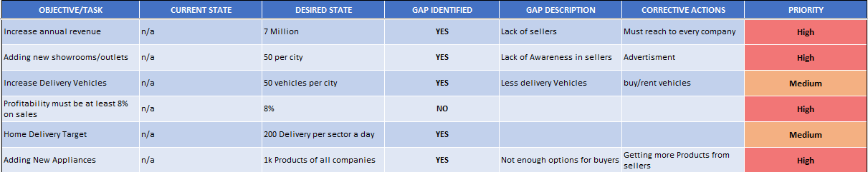

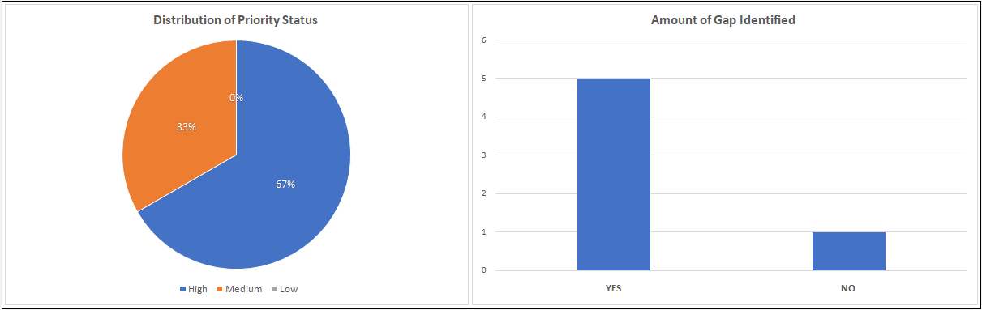

* **Proposed Solution**

this application will help people to buy their favorite appliances in low prices after comparing their prices and there will be no worry to hire a pickup or truck to make it to the home.

On the other hand, the outlets will be able to sell their products on this application and they also don’t have to do anything regarding the delivery to the customer and this will boost their selling.

* **Project Plan**

All the details of the project are mentioned via work breakdown structure although initial phase of the project is starts from the project manager who manage the whole project until deployment.

This is our university-based project final year. After suggestions of our supervisor and Panel we will contact maximum home appliances manufacturers and sellers/providers to add them in our project. We will also try to launch this Application. in Urdu language. Later we will add more features on it time to time.

* 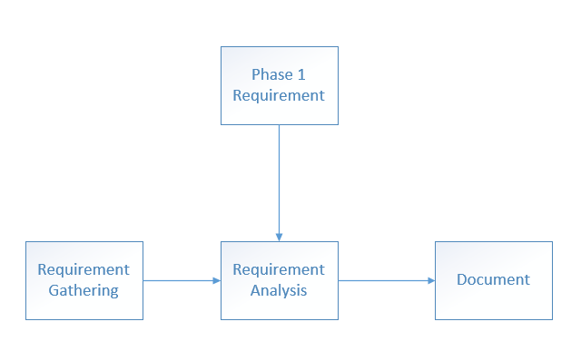**Work Breakdown Structure**

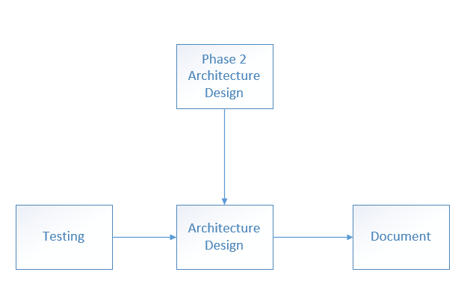

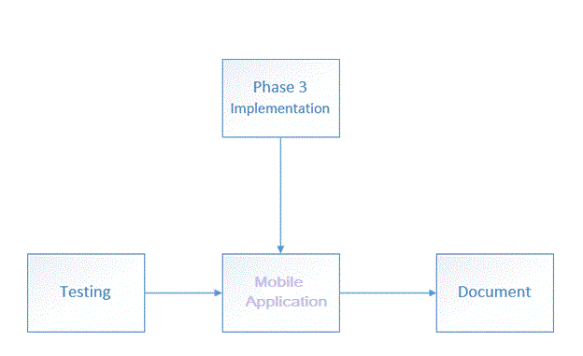

* **Roles & Responsibility Matrix**

|  |  |  |  |  |  |
| --- | --- | --- | --- | --- | --- |
| **WBS #** | **WBS Deliverable** | **Activity #** | **Activity to Complete the Deliverable** | **Duration**  **(# of Days)** | **Responsible Team Member(s) & Role(s)** |
| 1.1 | WBS | 1 | Meeting | 1 Week | Imran Hameed  Saba Razzaq |
| 1.4 | Scheduling | 2 | Meeting | 1 Week | Imran Hameed  Saba Razzaq |
| 2.1 | Documentation | 2 | Session | 2 Week | Imran Hameed  Saba Razzaq |
| 2.4 | UI Desing | 2 | Meeting | 3 Week | Imran Hameed  Saba Razzaq |
| 2.5 | How To Implements | 2 | Meeting | 4 Week | Imran Hameed  Saba Razzaq |
| 2.6 | Testing Apply | 2 | Meeting | 5 Week | Imran Hameed  Saba Razzaq |
| 4.1 | How to Advertisement | 4 | Marketing | 6 Week | Imran Hameed  Saba Razzaq |

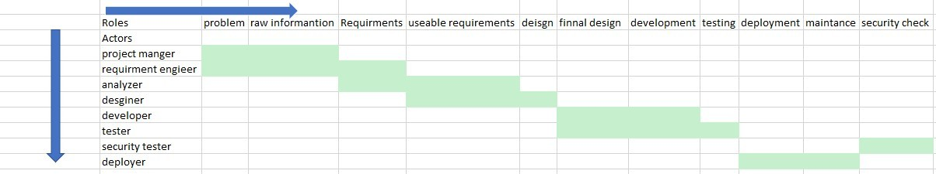

* **Gantt Chart**

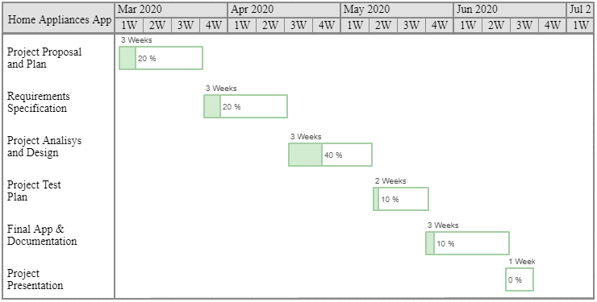

**CHAPTER 1 COMPLETED**